Pantajali Products Canada Inc

Designed By : Tejashvi Patel 2091776

Ajay Shrimali 2091622

Krutik Bhatti 2091641

Version: 0.1

Date: 23-March-2021

Document ID: Group

**Table of Contents**

1.Summary-----------------------------------------------------------3

2.Screenshots--------------------------------------------------------4

3.Test Cases---------------------------------------------------------12

4.References--------------------------------------------------------13

**1.Summary**

This website is built for the purpose of selling Indian based Ayurvedic Product of a company named Patanjali.In Canada,This product are not available in local vendor and depanneurs and large retail store like Walmart Inc.So this site will be useful for people who want to order specific product such as tablets,powder,juice and so on.

**2.Screenshots**

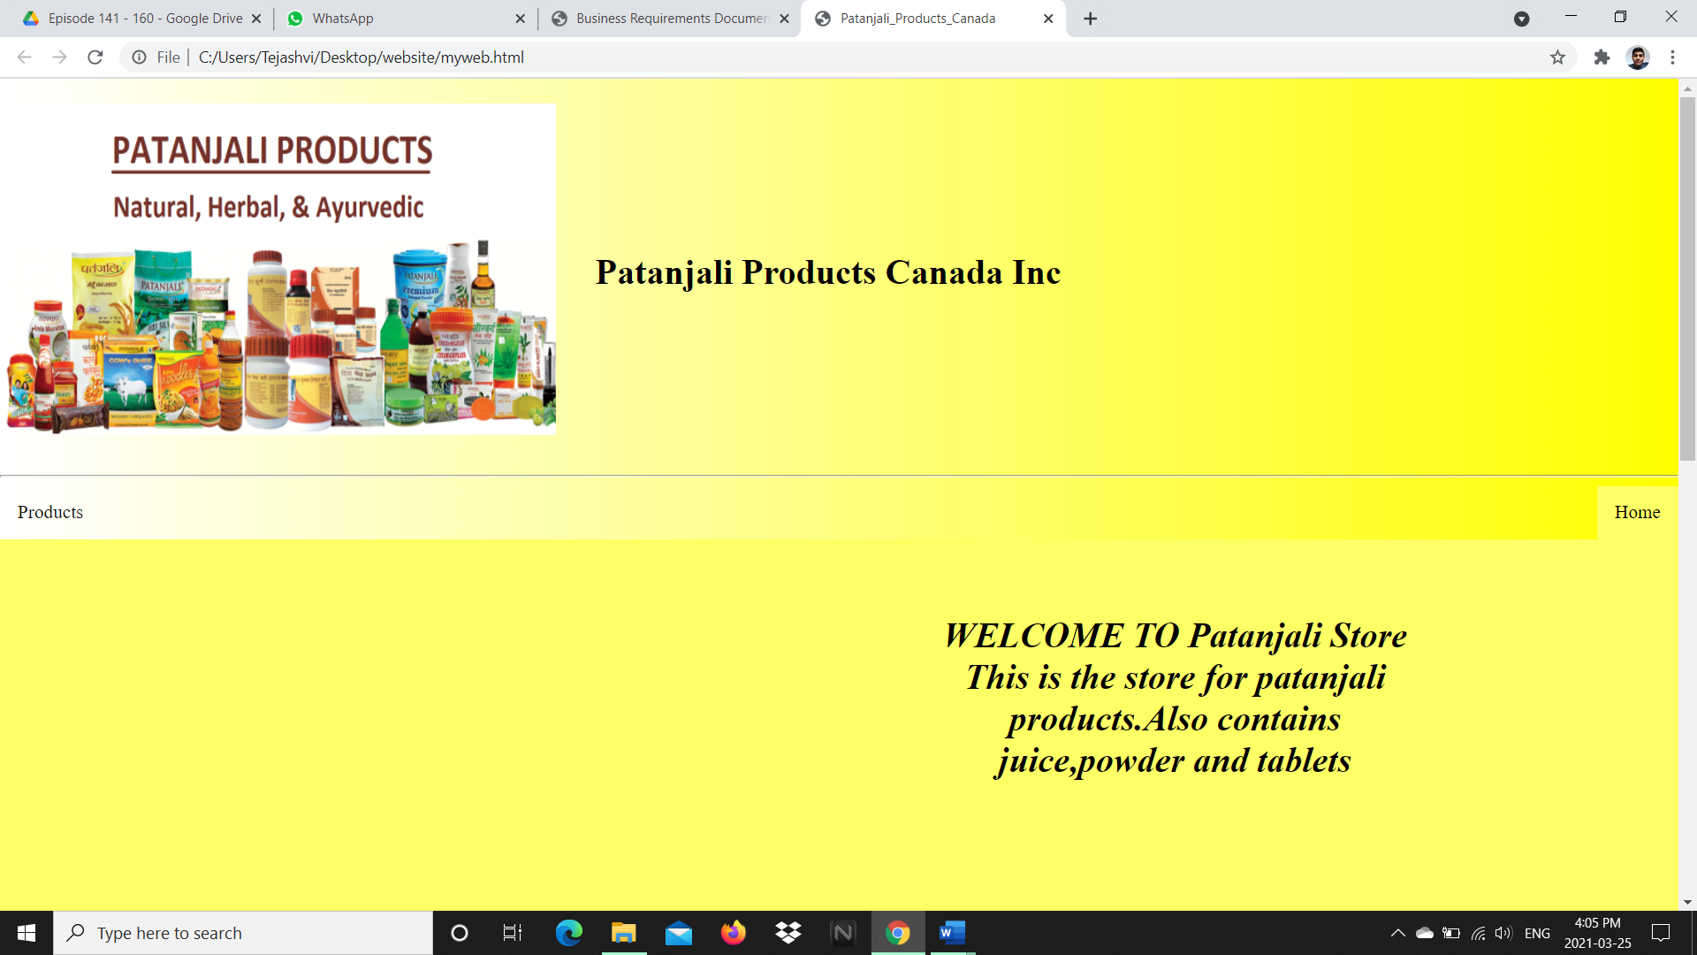

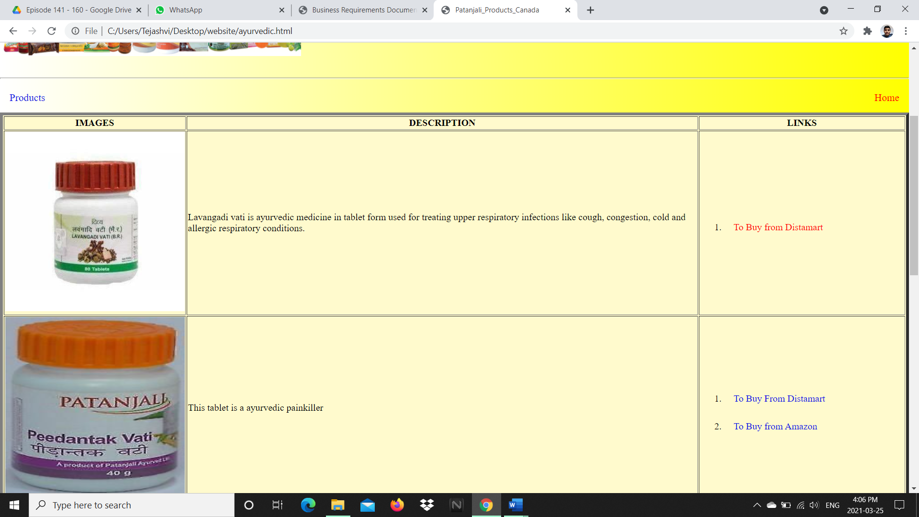

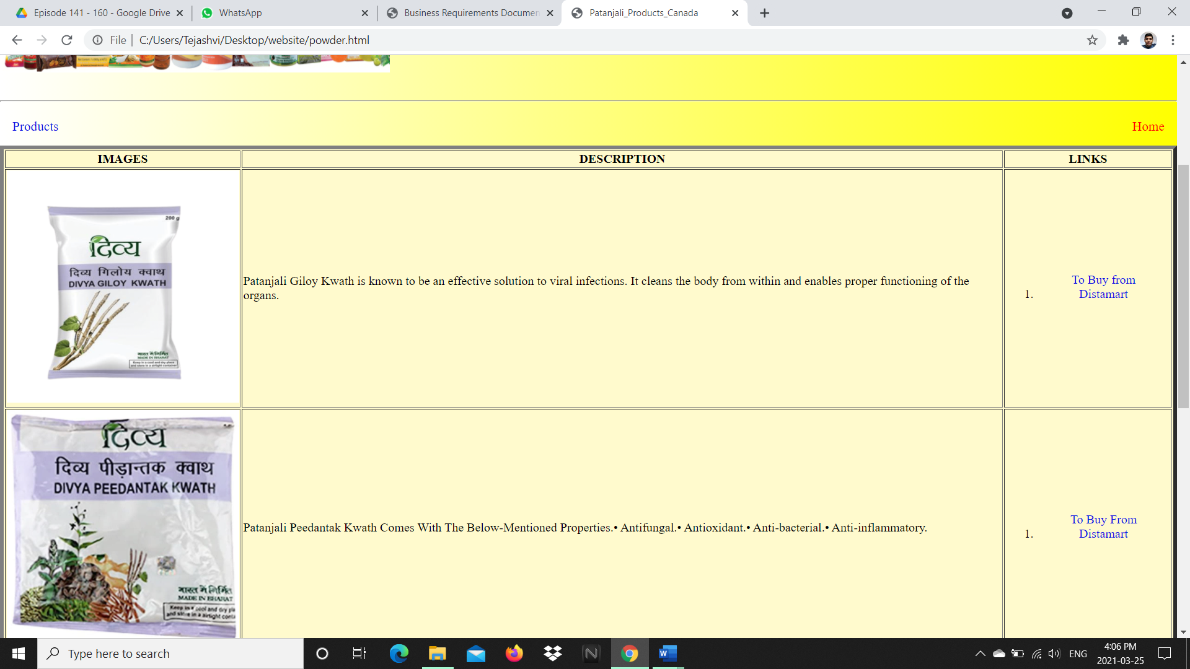

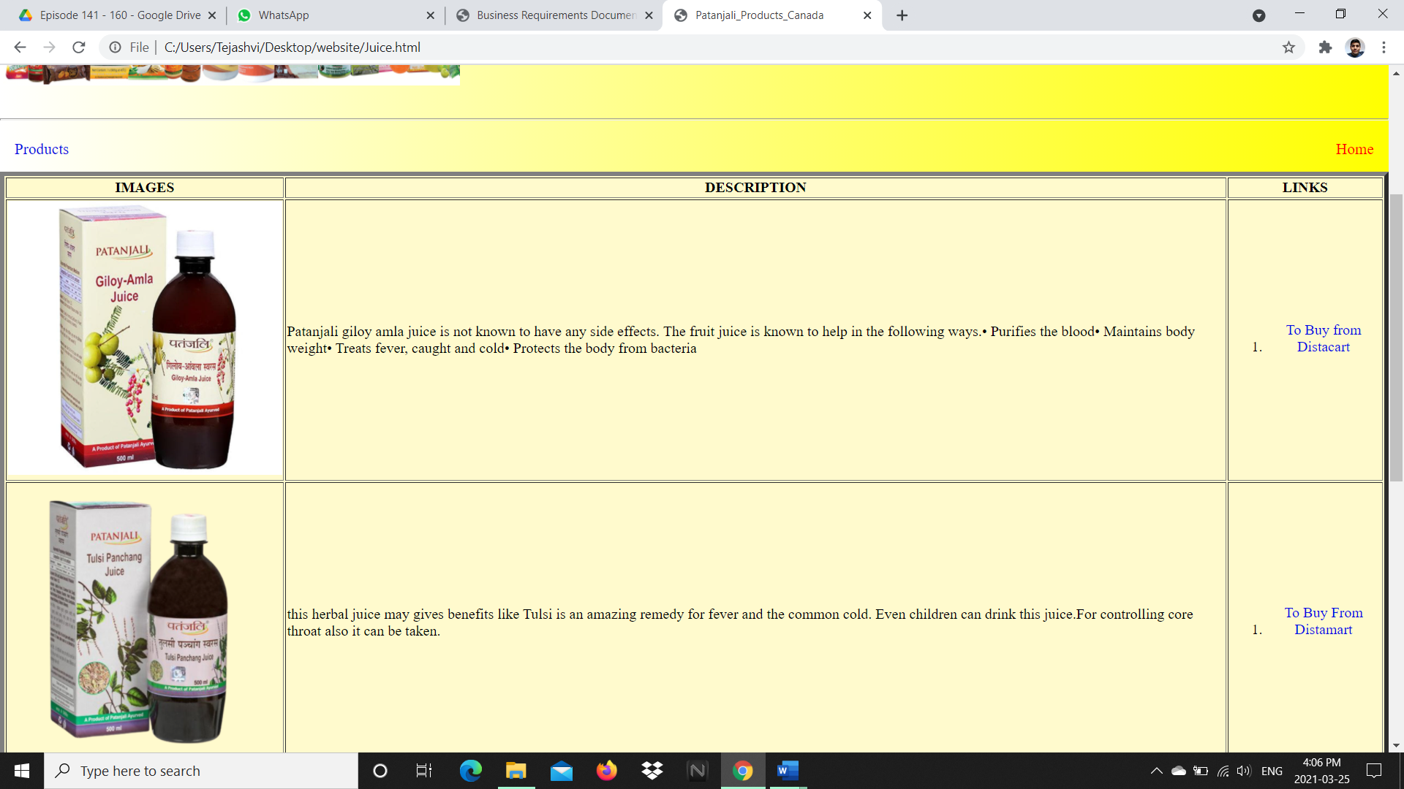

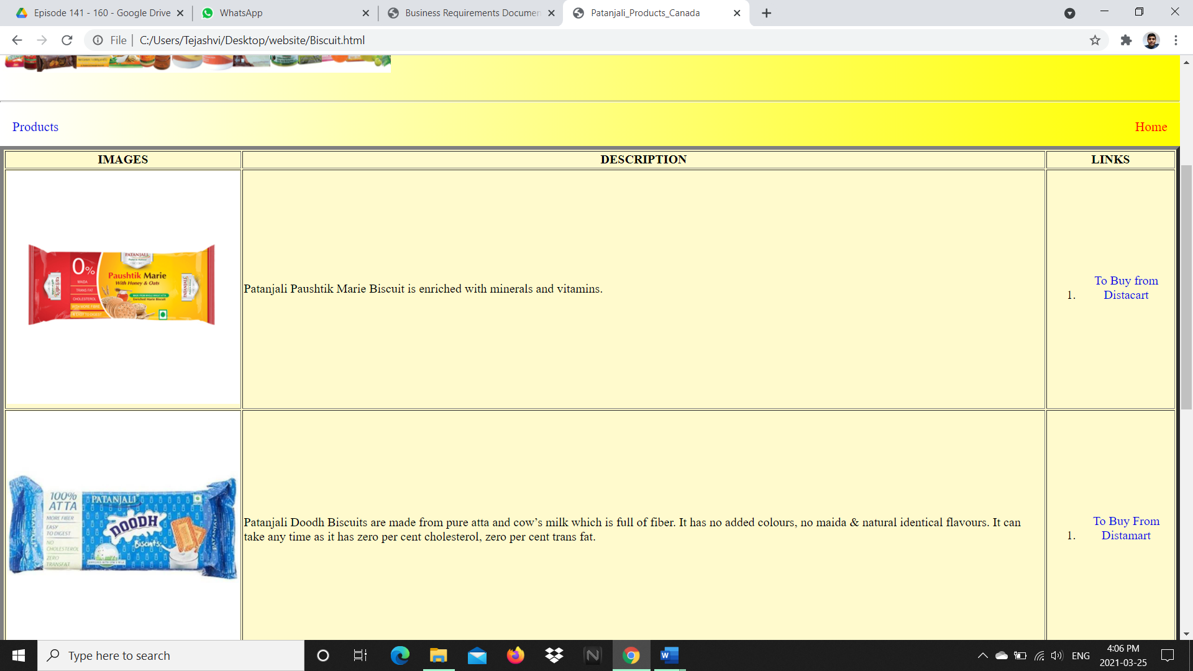

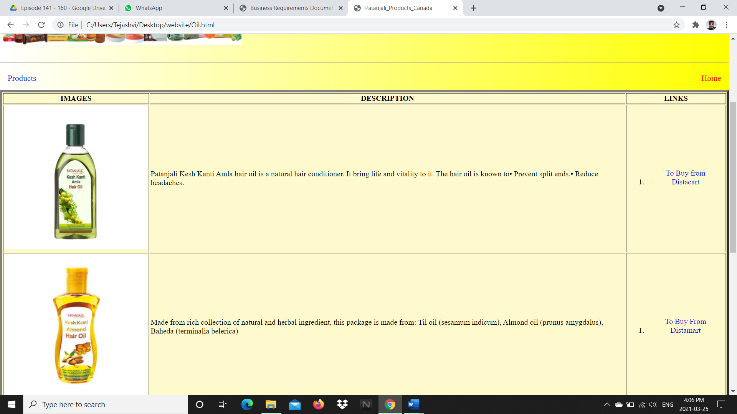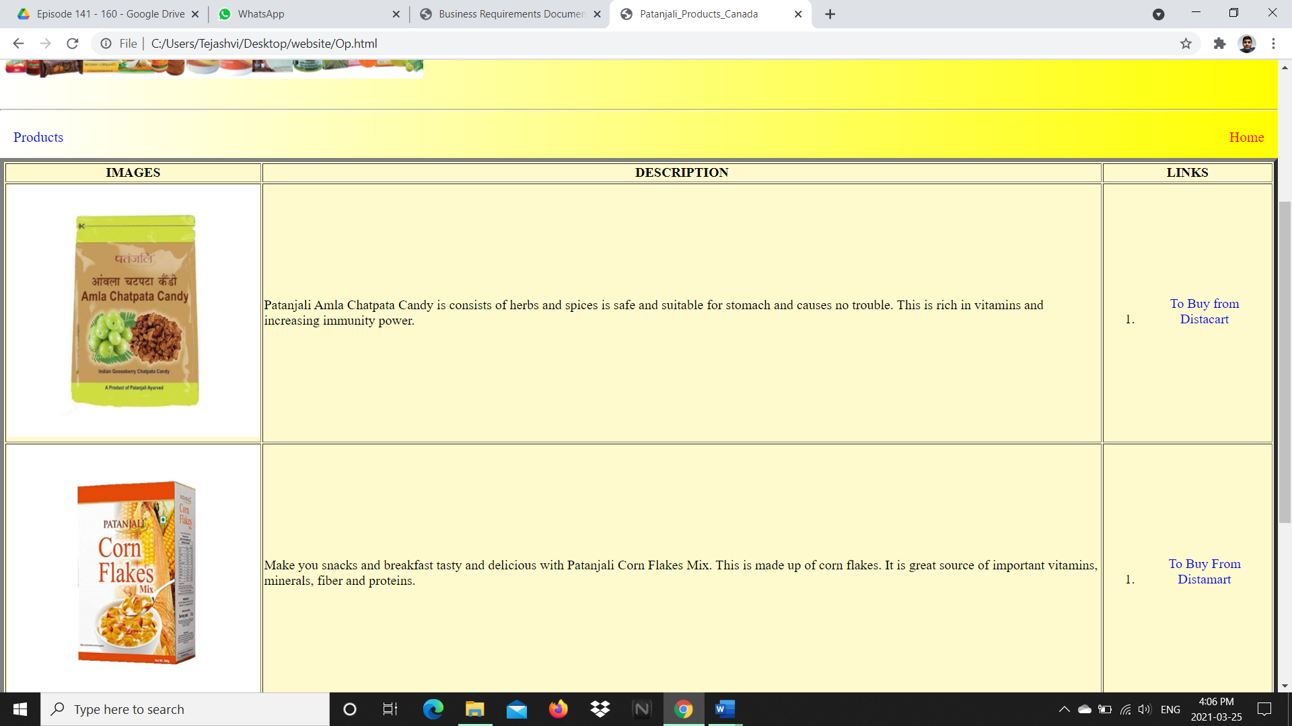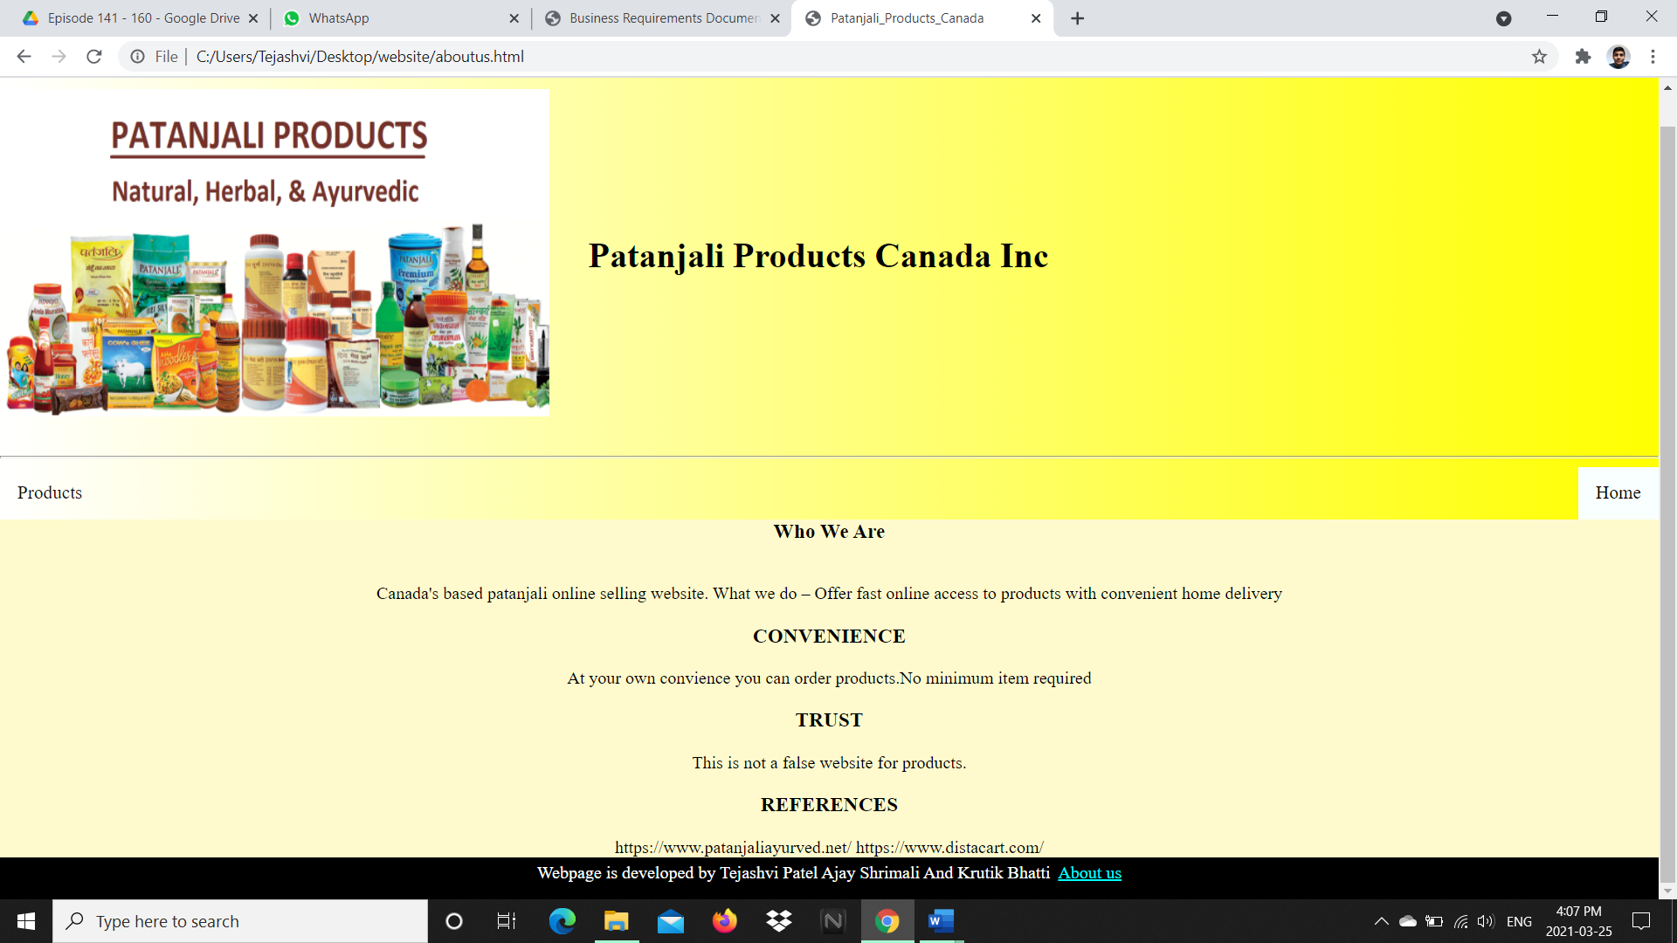

**3. Test Cases**

|  |  |  |  |  |  |  |  |  |  |  |  |  |  |
| --- | --- | --- | --- | --- | --- | --- | --- | --- | --- | --- | --- | --- | --- |
| **Step** | | **Test Steps** | | **Test Data** | | **Expected Result** | | **Actual Result** | | **Status (Pass/Fail)** | | **Notes** | |
|  | |  | |  | |  | |  | |  | |  | |
| 1 | | Navigate to login page | | User= example@gmail.com | | User should be able to login | | User is navigated | | Pass | |  | |
| 2 | | Provide valid username | | Admin | | User should be able to login | | dashboard with successful | | pass | |  | |
| 3 | | Provide valid password | | 123 | | Password correct | | Password correct | | pass | |  | |
| 4 | | Click on Login button | |  | | Logged in | | Logged in | | Pass | |  | |
| 5 | | Wrong user name | |  | | Pop of box showing that wrong username | | Pop of box showing that wrong username | | pass | |  | |
| 6 | | Wrong password | |  | | Pop of box showing that wrong password | | Pop of box showing that wrong password | | pass | |  | |
|  | |  | |  | |  | |  | |  | |  | |
| 7 | | Check payment | | Details about payment | | Check the payment options | | Check the payment options | | Pass | |  | |
| 8 | | Check price | | Details about price | | Check the shipping price | | Check the shipping price | | pass | |  | |
| 9 | | Check fronts | |  | | Seen clearly | | Seen clearly | | pass | |  | |
| 10 | | Check images | |  | | Seen clearly | | Seen clearly | | pass | |  | |
|  | |  | |  | |  | |  | |  | |  | |
|  | |  | |  | |  | |  | |  | |  | |
| 11 | | To buy products | | Click on link | | Its working | | Its working | | Pass | |  | |
| 12 | | After clicking on link | |  | | Refers to original website | | Refers to original website | | Pass | |  | |
| 13 | | Product description | |  | | Seen clearly on right side of product | | Seen clearly on right side of product | | pass | |  | |
| 14 | | Click on products | |  | | Showing all our products | | Showing all our products | | pass | |  | |
| 15 | | Click on about us | |  | | Showing our details | | Showing our details | | pass | |  | |

**4. References**

*https://www.patanjaliayurved.net/*

*https://www.distacart.com/*